 | [ Golf Cart Booking Saas platform] Requirement Survey and Design
 | Issue | 01
 | Date | 2026-05-18 Prepared By: Ayah Almahrouq


Contents
1 Required Deliverables 3
1.1 Business understanding 3
1.2 key business questions. Error! Bookmark not defined.
1.3 User roles 4
1.4 Proposed Database design 5
1.5 Entity Relationship diagram (ERD) 7
1.6 Business Roles Error! Bookmark not defined.
1.7 User stories 10
1.8 Simple Screen list 14
1.9 Sample Pages Wirefram (Skitched) 16
1.10 Reports 18
2 Practical Senario (Booking Conflict) 19
3 Change Request(2 service types) Error! Bookmark not defined.1

1. Required Deliverables

1.1 Business Understanding
- Pain Point: Manual / disorganized golf cart booking leads to conflicts, downtime, unpaid rides
- Users: Operations staff, admins, drivers, customers, managers
- Activities: Book, assign cart/driver, track maintenance, collect payment, report
- Notice: If The system in completely brand new, recommended solution is:
- BPMN diagram → to show the booking flow and business rules visually
- ERD → to show the data structure
- Business rules document → to explain the logic BPM models

1.2 Key Business Questions (≥10)
# | Area | Business Questions
1 | Customer Management | - Do you need to allow customers to book rides by themselves or will staff handle the booking process? (Do customers need to register/login?)  - In case customers book by themselves: what personal constraints apply to book? (Age, resident status in resorts/compounds, allowed identification constraints?)  - In case customers book by themselves: what software product do you request — a website, mobile application, or both?  - Which notification channels: SMS, Email, whatsapp, phone app notification?  - Is there a need for a customer support bot?
2 | Golf Cart Management | - How many zones/locations does the facility have?  - Do you plan to have a GIS for carts locations?  - Would you like to upload photos for registered golf carts?  - Battery threshold for "low battery" — is it configurable?
3 | Driver Management | - What is the driver working shifts system?  - Multiple drivers in the same shift or only one?  - What’s the allowed notification channels for drivers: SMS, Email, whatsapp, phone app notification?
4 | Booking Management | - Do you need a booking rate and feedback option?  - Who approves/confirms bookings — dispatcher/staff or automatically?  - What is the min/max booking duration (days/hours)?  - Can a cart be pre-booked days in advance or only same-day?  - How many booking requests do you daily/monthly expect or currently have? What are peak hours/days?  - What happens in case of customer no-show or cancellation?
5 | Available Rules | enforced by the system based on operational constraints
6 | Payment | - How is pricing calculated? Per hour? Zone-based? Driving type? Are taxes applied — if yes, what percentage?  - Would like the system to handle claims?  - Is there an option for promo-codes or voucher rides?  - How to handle a golf cart is already in reservation package?  - Do you apply occasional discounts?  - Is there integration with any payment gateway?  - Allow payment with foreign currencies/ local?
7 | Maintenance | - Is there a regular preventive maintenance system (monthly/yearly)?  - What about maintenance costs? — useful for financial reports
8 | Reports | - Would you prefer data visualization charts or data grid?  - What kind of statistics do you most need or request?

1.3 User Roles
- Admin: Full system access, manage staff, pricing, configurations and reports
- Operation staff: booking management and customer follow up
- Dispatcher: cart/driver assignment
- Driver: View assigned shifts, confirm rides
- Customer/Guest: Make bookings, view history, pay

1.4 Proposed Database Design
DB structure and tables details, properties and relationships proposed in ERD section
Table | Purpose | Who | Enumeration Properties
users | Authentication & authorization — login credentials, roles, active status | Staff, admins, drivers, customers (if they log in)
roles | Define system roles and their permissions | System / Admin | Role: (admin, staff, driver, customer)
user-role | Link users to roles | System
locations | Track zones, areas, and coordinates | Staff, Admin
customers | Business entity — the person booking and paying for the cart | Guests, resort visitors, registered users | id_type:(passport, ID card, license (if needed)
drivers | Business entity — the person driving the cart | Employees | Status:(available, on_shift, on_break, off_duty)
shifts | Define regular shifts timing | Staff
driver-shifts | Define each driver's working hours by day of the week | Staff, Drivers | day-of-week: (1: Monday -> 7: Sunday) (integer not num)
golf-carts | Physical asset — track cart identity, capacity, battery, and current status | Operations, Admin | Status:(active, under_maintenance, retired, out_of_service)
bookings [Determine Archive records/ period] | Core booking record — links customer, cart, driver, locations, time, and price | Staff, Customers | Status:(pending,confirmed, in_progress,completed,cancelled, no_show)  service_type:(self_drive, with_driver)
booking-status-history | Full audit trail of every status change on a booking | System, Staff, Drivers
payments | Financial record — track amount, method, promo codes, taxes, and payment status | Staff, Customers | method:(cash, card, digital_wallet, bank_transfer)  status:( pending, authorized, completed, failed, refunded, cancelled)
Maintaince-requests | Cart maintenance — type, priority, cost, start/completion dates | Staff, Drivers, Operations | maintaince_type:(preventive, repair, inspection, emergency)  priority:(low, medium, high, critical)  status: (pending, in_progress, completed, cancelled)
audit-logs | Activity log — every action by every user with key events and features | System

1.5 ERD
Check it online— https://lucid.app/lucidchart/Golf_cart_booking_ERD
[access email: hr.taheiya@gmail.com] or refer to the following PNG
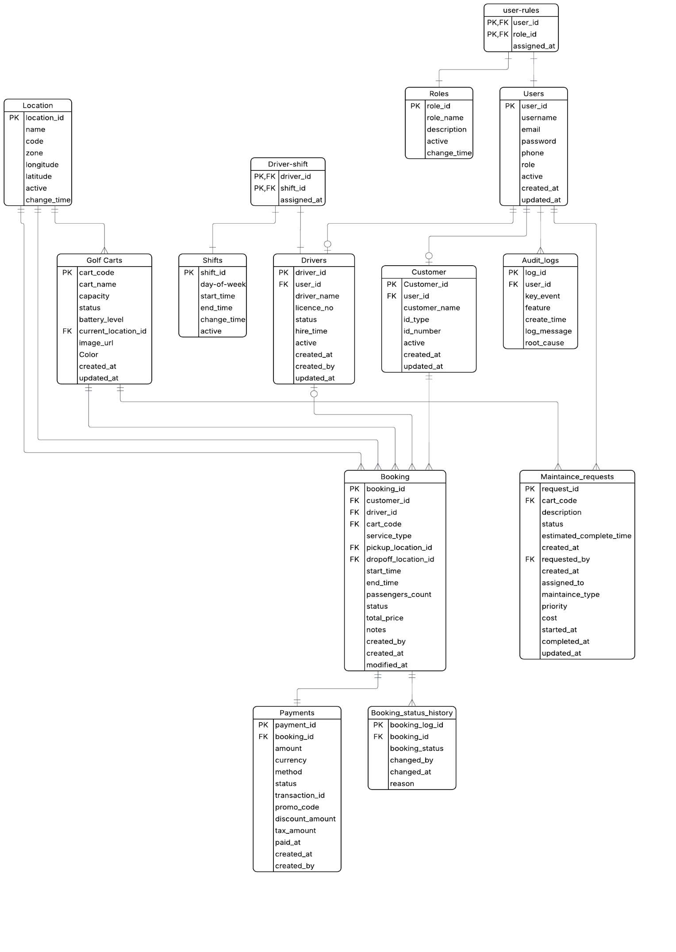

1.6 Business Rules (≥10)
# | Rule | Category | Description
1 | A cart cannot be double-booked (time overlap) | Booking | Can’t confirm a booking if the selected cart already has an existing confirmed booking with overlapping start/end times
2 | A driver cannot be double-assigned (time overlap) | Booking | Can’t confirm a booking if the selected driver already has an existing confirmed booking with overlapping start/end times
3 | A cart with status under_maintenance cannot be booked | Availability | A cart flagged as under_maintenance must be excluded from the available cart list and rejected at booking time
4 | A cart with battery below threshold cannot be booked | Availability | A cart with battery_level below its configured battery_threshold must be excluded from the available cart list and rejected at booking time
5 | Booking capacity must not exceed cart's max capacity | Booking | The passenger_count entered during booking must not exceed the selected cart's capacity field
6 | Self-drive = no driver assigned; With Driver = driver required | Booking | If service_type = self_drive, driver_id must be null. If service_type = with_driver, driver_id is required and cannot be null
7 | Driver must be on-shift at booking time | Booking | For bookings with service_type= with_driver, the selected driver must have a driver_shifts entry covering the booking's start_time and end_time
8 | Booking must be confirmed before the ride starts | Booking | A booking with status pending must be approved/confirmed by staff or payment before the start_time. The system should notify the staff for unconfirmed bookings approaching start time
9 | A cart must be restored to active when maintenance is completed | Maintenance | When a maintenance_request status changes to completed, the associated cart's status must automatically revert to active
10 | A deactivated user cannot log in or perform any action | Access Control | Any user with is_active = false must be denied login and blocked from performing any create, update, or delete operations
11 | All status changes on a booking must be logged in booking_status_history | Audit | Every time a booking's status field changes, a new row must be inserted into booking_status_history with the previous status, new status, user who changed it, and timestamp
12 | All create, update, and delete operations must be logged in audit_logs | Audit | Every significant action performed by a user on any entity must be recorded in audit_logs with old and new values in JSON format

1.7 User Stories (≥8)
# | As a.. | I want to... | So that... | Acceptance Criteria
1 | Guest / Customer | book a golf cart online by selecting pickup location, time, number of passengers, and driving type | I can reserve a cart in advance and avoid waiting | 1. Customer selects pickup and dropoff locations from the location list  2. Customer selects start and end time with available time slots  3. System calculates and displays total price with receipt details before confirmation  4. Booking is created with pending status and customer receives a booking reference
2 | Operations Staff | view and manage all bookings for today | I can monitor the daily flow, requests and respond to issues | 1. Dashboard shows today's bookings in a list or calendar view  2. Staff can filter by status (pending, confirmed, in_progress, completed, cancelled)  3. Staff can cancel a booking and provide a reason
3 | Dispatcher | Assign a cart or a driver | A booking can be confirmed | 1. can assign or change the golf cart/driver for a booking  2. When assigning a cart or driver, system highlights any time conflicts  3. Receives a clear error message listing the conflicting booking reference
4 | Driver | view my assigned shifts and upcoming bookings | I know my schedule and can prepare for each ride | 1. Driver logs in and sees a list of upcoming bookings assigned to them  2. Each booking shows pickup location, time, customer name, and passenger count  3. Driver can mark a booking as in_progress when starting the ride  4. Driver can mark a booking as completed when the ride ends  5. Driver cannot view or modify bookings assigned to other drivers
5 | Admin | Manage system configurations (Carts, shift, Users, Pricing, Drivers, Customers, locations) | All settings is always accurate and up to date | 1. Admin can create, edit, import, export, monitor and search golf carts, Locations/Zones, locations, Users, pricing, shifts, Drivers and customers
6 | Operations Staff | record a maintenance request for a golf cart | the cart is taken offline for repair and does not get booked | 1. Staff creates a maintenance request linked to a specific cart 2. Staff selects maintenance type (preventive, repair, inspection) and priority (low, medium, high)  3. On save, the cart status automatically changes to under_maintenance  4. System prevents any new booking from using this cart  5. Staff can mark the maintenance as completed, which restores the cart to active status
7 | Customer | apply a promo code or voucher to my booking | I can receive a discount on the total price | 1. Customer enters a promo code on the booking form before confirming  2. System validates the promo code against active promotions  3. If valid, discount amount or percentage is applied and new total is displayed  4. If invalid or expired, system shows an error message and does not apply the discount  5. Promo code, original price, discount, and final price are stored in the payments record
8 | Admin | view operational reports on bookings, revenue, cart utilization, and maintenance | I can make data-driven decisions about the fleet | 1. Admin selects a report type and date range  2. Booking report shows total bookings by status and by day  3. Revenue report shows total income, taxes, and discounts applied per period  4. Cart utilization report shows booked hours vs. available hours per cart 5. Maintenance report shows total maintenance cost and frequency per cart  6. All reports can be exported or printed
9 | Operations Staff | record and track customer booking history | I can quickly resolve disputes and provide good customer service | 1. Staff searches for a customer by name, mobile, or email  2. Staff views all past and current bookings for that customer  3. Each booking shows status, total price, and payment status  4. Staff can update customer contact details 5. Staff cannot delete customer records — only deactivate them
  - Simple Screen List
# | Screen | Main Functions
1 | Login (Authentication) | 1. User enters credentials and logs in  2. System validates role and redirects to appropriate page.  3. Failed login attempts are logged and user is notified
2 | Dashboard (Home) | 1. Display today's bookings with ability to filter with different booking status, cart availability, and driver’s availability.  2. Display today’s returning list and allow operation staff to confirm  3. Quick-access for to the most common actions (new booking, assign driver, assign cart)
3 | Customer Management | 1. Create, Display, edit, import, export and deactivate.  2. Search for customers by name, mobile, or email
4 | Golf Cart Management | 1. Create, Display, edit, import, export and deactivate.  2. View cart status, battery level, current location/zone, and maintenance history, allow filters.  3. Show alerts for low-battery carts, upcoming maintenance
5 | Driver Management | 1. Create, Display, edit, import, export and deactivate.  2. Assign and manage driver working shifts by day of week  3. View driver's assigned bookings and shift schedule
6 | Location/Zone Management | 1. Create, Display, edit, import, export and deactivate.
7 | Booking Form | 1. Create a new booking by selecting customer, pickup/dropoff locations, and time  2. System validates all availability rules before saving (time overlap, battery, maintenance, capacity)  3. Calculate and display total price including any applied promo code or discount
8 | Booking management | 1. View all bookings with filter by status, date, location, and customer  2. Confirm, cancel, or update booking details and reassign cart or driver  3. View full booking history including all status changes and linked payment
9 | Payment | 1. Record and view payments with method, amount, promo codes, discount/tax and status.  2. Track paid, pending, and failed payments across all bookings
10 | Maintenance Management | 1. Create, Display, edit, import, export and deactivate maintenance requests linked to specific carts  2. Update maintenance status from pending → in_progress → completed and so on cart status.  3. Record maintenance cost, type, priority, and completion date.
11 | Reports | 1. Display periodic booking volume, cart utilization, and driver performance reports  2. Display periodic payment summary and maintenance cost reports  3. Filter reports by date range, zone, cart, or driver and export to printable format
12 | Audit Logs | 1. View all system actions performed by users with timestamps  2. Filter logs by user, key event, feature, and date range 3. View old and new values for any logged change in JSON format

1.9 Sample pages wireframe (Skitch)
- Dashboard / Home can be accessed by dispatcher/ operation staff

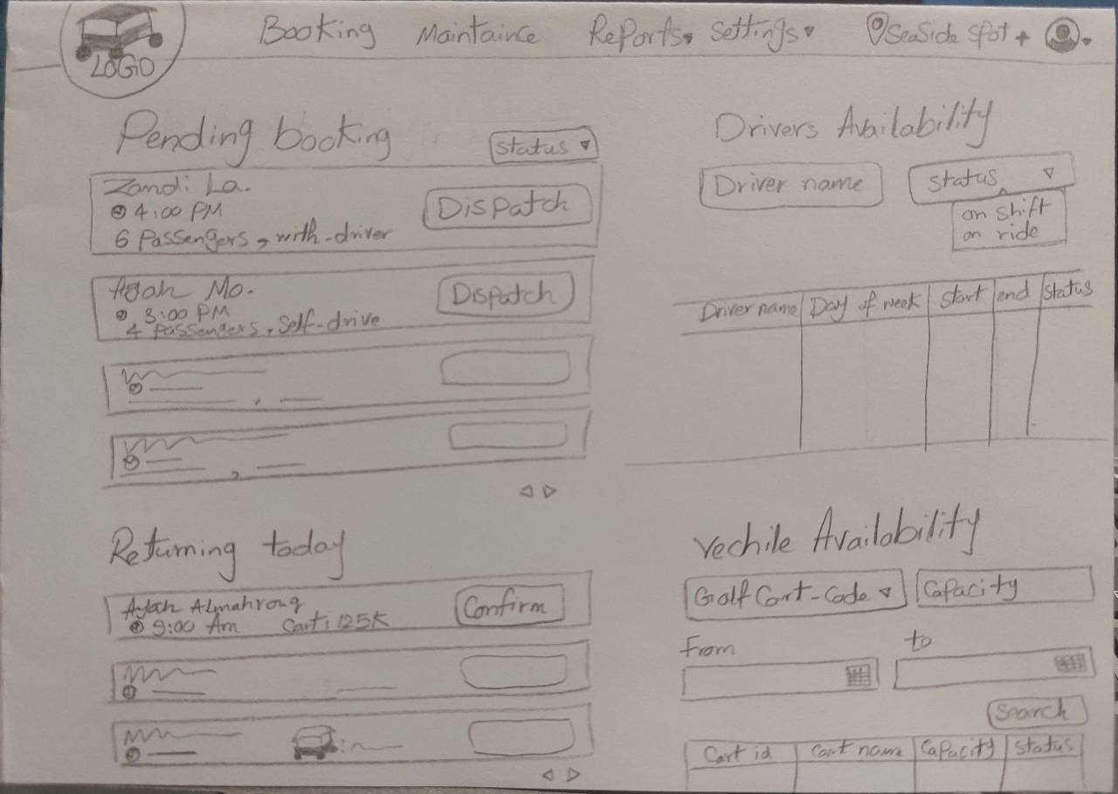
- Booking Form can be accessed by operation staff/ customer

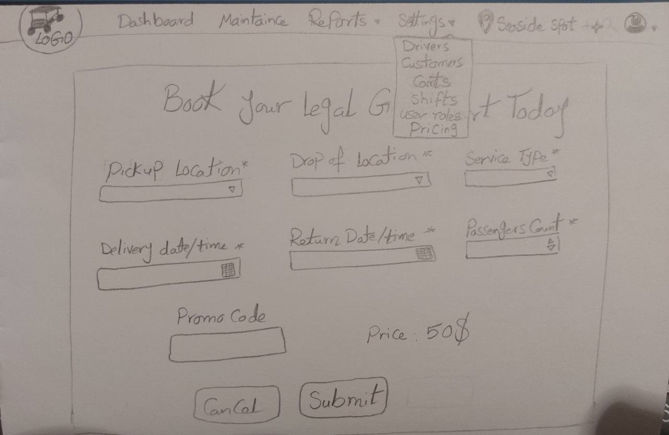
- Higher management Report for complete system performance

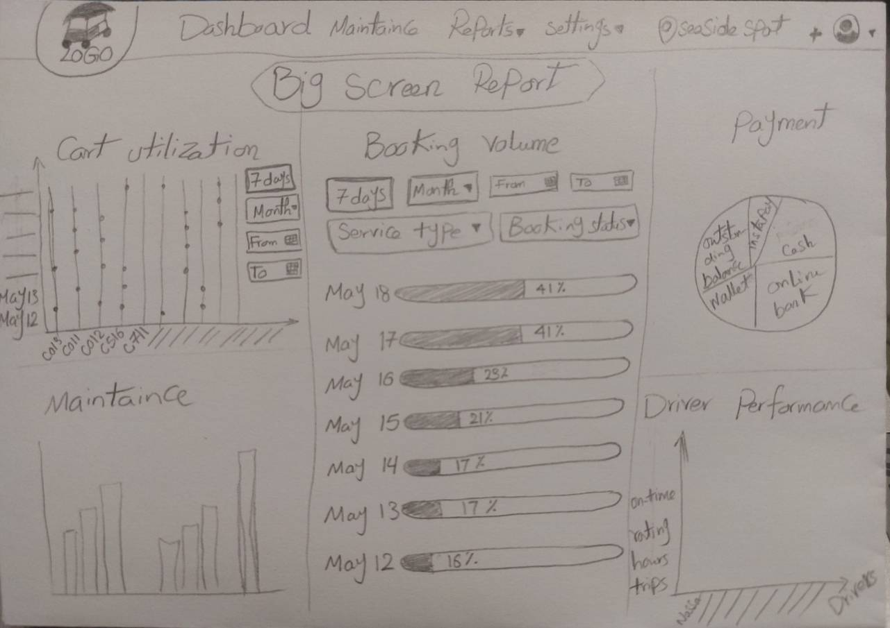

1.10 Reports (≥5)
# | Report Name | Description | Key Metrics | Filters
1 | Booking Volume Report | Track total number of bookings over time | Total bookings by status (pending, confirmed, completed, cancelled); bookings by service type (self_drive, with_driver); average booking duration | Daily, weekly, monthly; by date range
2 | Cart Utilization Report | Measure how efficiently the fleet is being used | Booked hours vs. available hours per cart; utilization % per cart and per zone; idle time per cart; most and least utilized carts | Per cart, per zone, by date range
3 | Driver Performance Report | Evaluate driver productivity and reliability | Trips completed per driver; hours worked; on-time pickup rate; average trips per shift; no-show rate | Per driver, by date range, by shift
4 | Payment Report | Track income and payment status across all bookings | Total revenue; paid vs. unpaid; revenue by payment method; discounts and taxes applied; failed payment attempts; outstanding balances | By date range, by payment status, by payment method
5 | Maintenance Report | Monitor cart health and maintenance costs | Total maintenance requests by type and priority; maintenance cost per cart; average cart downtime; time between maintenance cycles | Per cart, by type, by priority, by date range

2. Practical Scenario: Booking Conflict

Situation: Book CART-001 3:00–4:00 PM, but it already has a booking 3:30–4:30 PM.
Answer:
- Reject the new booking. Overlap detected.
- Why: A cart cannot be serving 2 orders at the same time. Overlapping time ranges create a conflict.
- Detection: Check if any confirmed booking for the same cart has a time overlap with the new request.

SQL Query:

SELECT * FROM bookings
WHERE golf_cart_id = 'CART-001'
AND (status = 'confirmed'
AND start_time < '16:00' -- new booking end
AND end_time > '15:00'; -- new booking start

ChangeRequest:Two Service Types

Q1: What changes needed in booking design?
- Add service_type field to bookings (self_drive | with_driver)
- Make driver_id nullable (required only for with_driver)
Q2: Is driver assignment always required?
- No — only required for with_driver type. Self-drive = no driver.
Q3: Where to store service type?
- bookings table as service_type enum/column
Q4: New business rules:
- Self-drive bookings must verify customer has valid license/approval
- With-driver bookings must ensure driver is on-shift during booking window
- Pricing may differ by service type
- Maintenance status applies to both types equally

